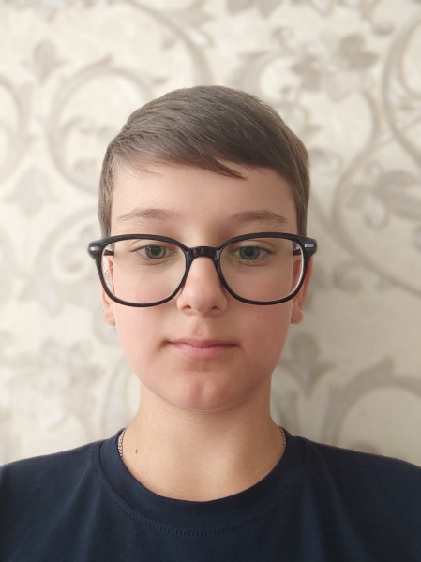
Maxim Chabanov
Front-end Developer

Date of birth: 1st September 2009 (11 years)
Country of residence: Ukraine
E-mail: maxchabanov2009@gmail.com
Phone: +38(068)9149788
Telegram: @MaximChabanov

My Skills

Html/CSS Jquery
Bootstrap Npm
Tailwind CSS Figma
JavaScript Jira
Github/Git

About Me

Hello! I’m Max. I’m a front-end developer. I am currently working in a small company as a JavaScript programmer. Besides development, I like exercising and cycling. My English level is intermediate.
I have an experience of half a year, and I have 3 projects. I would love to take small tasks and bring them to life ;)

My Projects

My Website
05.05.2021 – 07.06.2021 (half a month)
https://maxchabanov.github.io/my-website/

Skills used: Html, CSS, JavaScript

CSS Animations
12.04.2021 – 15.04.2021 (3 days)
https://maxchabanov.github.io/bike-animation/
https://maxchabanov.github.io/slide-animation/
https://maxchabanov.github.io/button-animation/

Skills used: Html, CSS, SVG

Navbar
09.07.2021 – 14.07.2021 (5 days)
https://maxchabanov.github.io/navbar/

Skills used: Html, CSS, SVG, responsive layout

